**Wilfel John Madrigal Mambalo**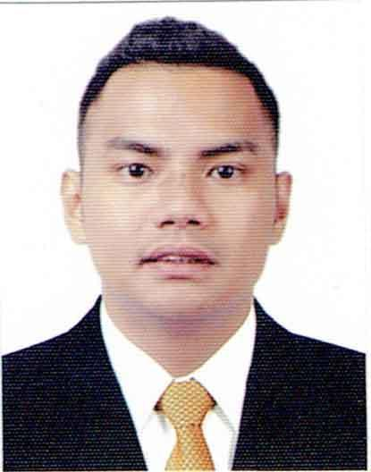

Lot 55 Rd 21 Ph.3 Cogeo Village Antipolo, City

Contact No.: +639602762309

E-mail: mambaloanthonyjayjay@gmail.com



**PERSONAL DATA** Born on 2nd of August 1993 to Felipe C. Mambalo and Leny M. Mambalo. Can efficiently work alone under pressure or can even be a team player. Fluent in Filipino and English languages.

**WORK EXPERIENCES**

* The Aristocrat Restaurant - Oct. 26 to Dec. 26 2016
* Garage 88 Burgers and Beers - May 29 to Aug. 10, 2016
* Buffalo Wild Wings (KSA) - Sept. 24, 2017 to Sept. 24, 2019
* Operation Falapel (KSA) - Aug 20,2020 to Feb 24, 2022
* Cinnabon (KSA) - Feb 24 2022 to Feb 24 2023

**EDUCATION**

**TERTIARY EDUCATION**

**Technological Institute of the Phil.** (2011-2014) Aurora, Quezon City Marine Engineering

**SECONDARY EDUCATION**

**East Manila Integrated School**

(2005-2009) Cogeo Gate 2 Antipolo,City

**TRAININGS**

* **Magsaysay Institure of Hospitality and Culinary Arts**

3rd fl. Times Plaza Bldg.United Nation Avenue Cor. Taft Ermita Manila on **Dec. 07 to May 06, 2016**

* **English Proficiency Training**

3rd fl. Times Plaza Bldg. United Nation Avenue Cor. Taft Ermita Manila on **Feb 29 – March 04, 2016**

* **Barista NCII (amended)**

TESDA PAMAMARISAN

**SKILLS**

- Computer Literate (Microsoft Word)

- Professionalism

- Foam art

- Alcohol Mixing

- Basic latte art

- Ordering procedures

- Food preparation and safety

- POS system

- Up selling

- Speedy and efficient

- Strong communication

- beverage preparation

- Safe food handling

- Teamwork and collaboration

**ACHIEVEMENTS**

* Player of the month (Dec. 2018)
* All BWW First Team (Feb. 4, 2019)